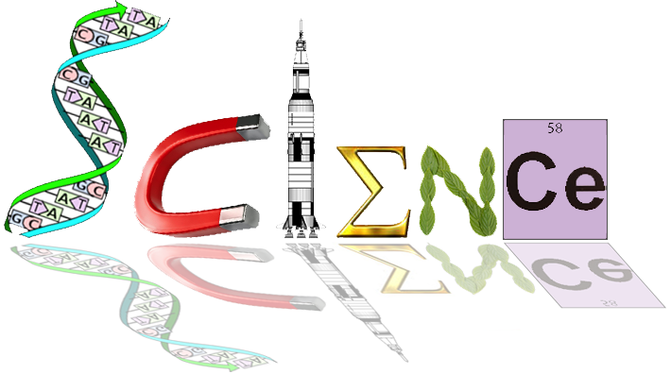


Year 12 ATAR Human Biology
The Immune Response
Test 3 (Task 7), 2018
Total mark: ____ /60

MULTIPLE CHOICE SECTION: ___ / 20 MARKS

- Which of the following statements about bacteria is correct?
- Most bacteria have no ill effects on our health.
- It is unusual to have bacteria in or on the body.
- Bacteria can be identified by their location in the body.
- Bacteria cause diseases including influenza and warts.

- Viruses:
- cause diseases by secreting toxins from vesicles.
- can be identified using an ordinary light microscope.
- cause diseases by invading human cells.
- lack genetic material.

- A disease that it normally present in a population (at a particular prevalence) is:
- pandemic.
- outbreak.
- endemic.
- epidemic.

- One example of a protective reflex that protects against infection is:
- acidic skin.
- cilia.
- flushing.
- sneezing.

- Phagocytes:
- make heparin.
- release histamines.
- can engulf and digest micro-organisms.
- secrete pus.

- Inflammation:
- is decreased by histamines.
- only occurs in specific tissues or organs.
- is stimulated by mast cells.
- is stimulated by macrophages.
- The inflammatory response includes all of the following except:
- blood vessel constriction.
- temperature increase.
- increased blood flow.
- phagocyte attack.

- Fever can work to defend against pathogens by:
- inhibiting the growth of some pathogens.
- killing infected body cells.
- causing shivering.
- causing vasoconstriction restricting the movement of pathogens.

- Neutrophils and monocytes reach an infection site from the bloodstream because:
- the blood vessels rupture at a site of infection
- neutrophils and monocytes are amoeboid; they squash against, and pass through, capillary walls.
- they are small and diffuse across membranes just like food and gas molecules.
- they move upstream in the lymphatic system

- Pus indicates that ______________.
- body tissues are dying.
- the body is trying to overcome infection.
- too much lymph has built up.
- the inflammatory response has failed to defend against bacterial invasion.

- Mechanical barriers, such as surgical masks, work to reduce transmission of pathogens by:
- killing pathogens before they enter the body.
- providing an obstacle to pathogens entering the body.
- washing away pathogens.
- reducing inflammation.

- Which type of immunity is demonstrated when a mother’s antibodies transfer to a baby via the placenta or breast milk?
- Natural, passive immunity.
- Artificial, passive immunity.
- Natural, active immunity.
- Artificial, active immunity.

- The advantage of naturally acquired, active immunity is that:
- it is usually long lasting, sometimes for life.
- it can develop without exposure to an antigen.
- it produces antibodies against a wide range of infective agents.
- it immediately provides high levels of antibodies upon first exposure.
- Various surgical treatments for breast cancer require the removal of some or all of the lymph nodes in the axilla (armpit). The would likely result in:
- improved ability of the body to fight infection.
- reduced spread of communicable pathogens around the body.
- reduced volume of lymph.
- swelling (oedema) of the arm where lymph nodes were removed.

- Which of the following statements is NOT correct?
- T cells form in the bone marrow but mature in the thymus.
- Monocytes give rise to macrophages, which are involved in both specific and non-specific responses.
- Eosinophils are involved in anti-parasitic and bactericidal activity.
- B cells trigger the inflammatory response.

- Antigen presenting cells (APCs):
- can be macrophages. Is this not the correct response
- help B cells recognize a specific antigen.
- are types of antigens.
- are types of receptors on B and T cells.

- Antibiotics are often ineffective against viruses because viruses:
- keep changing their external protein coat.
- are able to disguise themselves in the host cell membrane.
- are not true living cells, so their metabolism is not affected by antibiotics.
- can destroy or inhibit the actions of antibiotics in living cells.

- When a person is exposed to a disease for which they have been vaccinated, it is likely:
- they will never come in contact with the disease agent.
- they will show immediate symptoms of the disease.
- they will fight off the disease quickly.
- they will die.

- Which of the following diseases is not vaccinated against using living attenuated vaccines?
- Measles.
- Rabies.
- Yellow fever.
- Human papilloma virus.

- Tony cut his foot on a piece of rusty metal and had to go to the doctor to have stitches. The doctor also gave him an injection to prevent him from contracting tetanus.
The immunity that Tony gained from having the injection was
a. passive and artificially acquired.
b. passive and naturally acquired.
c. active and naturally acquired.
d. active and artificially acquired. This is correct

SHORT ANSWER SECTION: ___ / 25 MARKS

- What are the three types of T-lymphocytes and what role does each play?
(6 marks)
Killer T cells, CD4: attacks cells with foreign antigens directly and destroy them
Helper T cells, CD8: assist in the activation of B cells and killer T cells
Suppressor T-cells: supress the activity of B cells and T cells so antigen is tolerated.
switch off immune response once antigens have been destroyed.

- Antibiotics revolutionised the treatment of infections.
- Identify the two key types of antibiotics and explain how they differ. (3 marks)
Bacteriostatic antibiotics: inhibit bacteria growth / interfere with protein synthesis allowing the immune system to overcome the infection.
Bactericidal antibiotics: destroy bacterial pathogen by targeting outer cell walls, inner cell membranes or metabolism pathways of bacteria.

- Antibiotic resistance threatens the effective prevention and treatment of an ever-increasing range of bacterial infections. Suggest two factors that promote antibiotic resistance and two strategies to address this issue. (4 marks)
Overuse of antibiotics in treatment of diseases
Overuse of antibiotics in food-producing animals
People stop taking antibiotics when symptoms disappear
Antibacterial ingredients in cleaning agents favour the survival of antibiotic resistant
strains of bacteria
- Why are antivirals more difficult to develop than antibiotics? Any 1 (1 mark)
Resistance due to rapid mutation
Labour intensive and expensive
Viruses are intracellular parasites make targeting more difficult to avoid host toxicity

- The diagram below shows one of the actions of antibodies on pathogen. 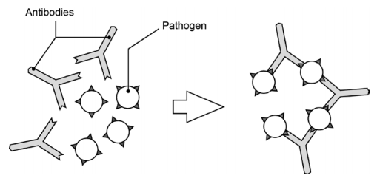
- What action of antibodies does the diagram represent? (1 mark)
Agglutination/clumping together of the pathogen
- Describe three other ways in which antibodies can act on pathogens to help fight infection. (3 marks)
combine with foreign bacterial toxins
Inactivate/neutralise/produce toxins
binds to surface of viruses
enhance phagocytosis
prevent viruses decoating ( any three reasonable responses)
- Name the type of lymphocyte responsible for the production of antibodies. (1 mark)
B cells/ B lymphocytes/ plasma cells

- The graph below shows the immune response of two people, one of whom has been vaccinated against a disease and the other not.
.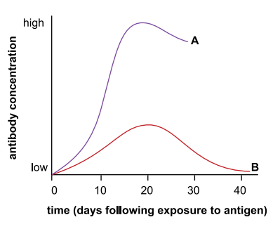
- Identify the person (A or B) who has been vaccinated and explain your answer.
(2 marks)
Person B
Initiates primary antibody response.

- In the later stages of the infection, a person infected with HIV would show a different pattern to either of these curves. Describe and account for this difference. (2 marks)

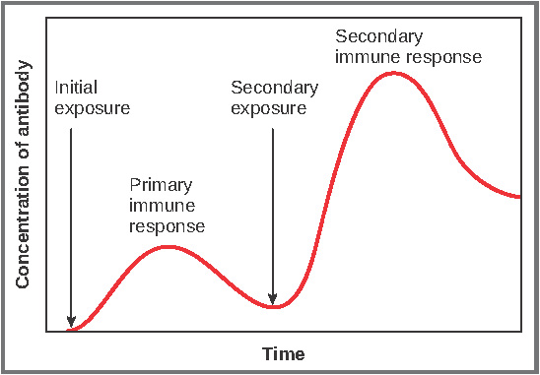
Response after 1st exposure takes longer due to antibodies don’t appear immediately

More antibodies are produced after 2nd exposure due to memory cells.

- This particular disease requires a booster dose of vaccine. Explain why some vaccines need boosters, and why they have a specific schedule. (2 marks)
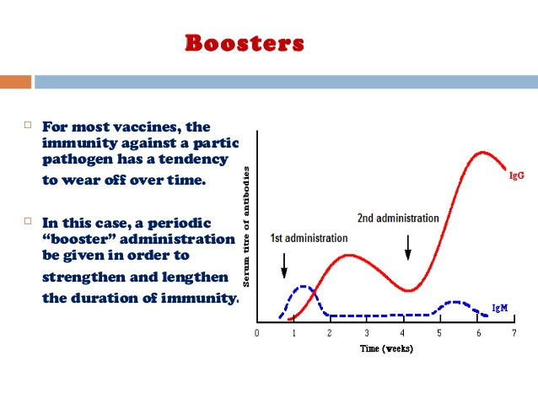
EXTENDED ANSWER SECTION: ___ / 15 MARKS
Kidney infection (pyelonephritis) is most commonly caused by Escherichia coli bacteria. If a person is infected with Escherichia coli, antibodies are produced to fight the infection.

Outline the immune response that produces antibodies (8 marks)

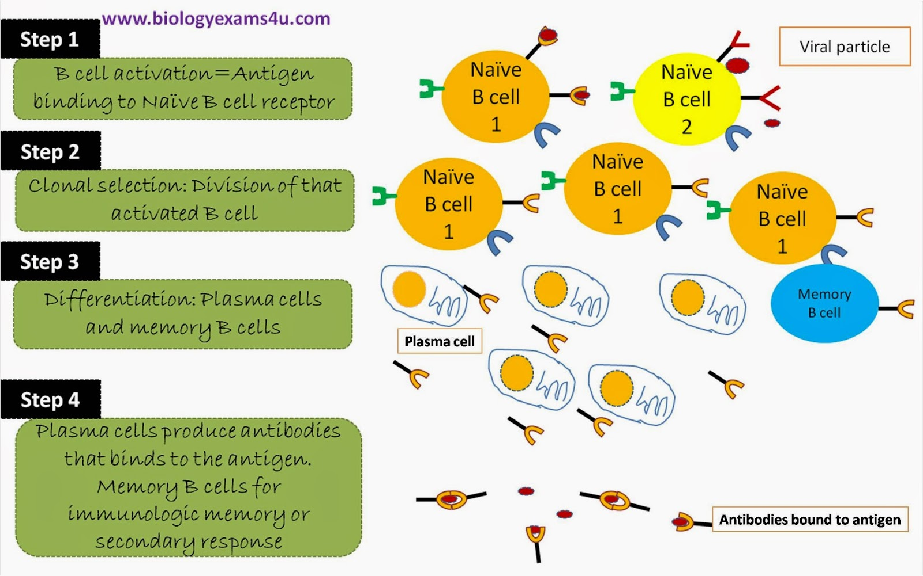

Unfortunately, an untreated renal infection can progress into renal failure.
A child with a defective kidney received a new kidney transplanted from a non-related male. This patient failed to take the appropriate medication and the transplant was rejected.

Describe the cell-mediated immune response that resulted in the rejection of the transplanted kidney. (7 marks)
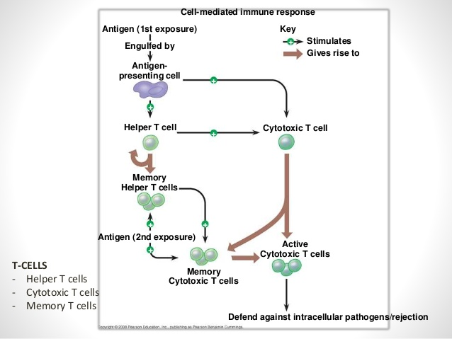

Tissue rejection is due to T-cells
T-Cell mediated response against foreign Major Histocompatibility Complex in the donated organ

T-cells destroy graft tissues
hypersensitivity directed against the foreign MHC molecules which look like self-MHC presenting a foreign antigen.

Pre-formed anti-donor antibodies bind to graft endothelium immediately after transplantation cause damage to graft tissue

